

**SOFTWARE DEPARTMENT**

**EMPLOYEE INFORMATION OF**

**REDWANUL HAQUE IFTY**

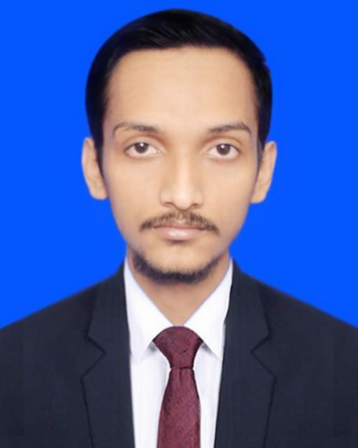

**1. Personal Information**

* **Name**: Redwanul Haque Ifty
* **Date of Birth**: 17th November 1999
* **Address**: Ghoradia, Narsingdi, Bangladesh
* **Contact Number**: (+880) 1743762775
* **Email**: ifty8555@gmail.com
* **Nationality**: Bangladeshi
* **Marital Status**: Single

**2. Educational Background**

* **Highest Degree**: Bachelor in Science (BSc) in Computer Science & Engineering
* **University/Institution**: American International University Bangladesh
* **Graduation Year**: 2023
* **Major**: Software Engineering

**3. Work Responsibility In Tizaraa**

* Develop and maintain server-side logic and APIs.
* Collaborate with frontend developers to integrate user-facing elements.
* Write clean, efficient code following best practices.
* Troubleshoot and debug backend issues.
* Optimize database queries and performance.

**4. Work Experience**

* **Company:** Company 1
* **Designation**: Assistant Officer
* **Company Name**: EnterKeyBD.
* **Start Date**: December 2023
* **Key Responsibilities**:
  + Assist in daily IT operations, including software maintenance, troubleshooting issues, and providing technical support to staff.
  + Monitor system performance and security, ensuring all IT systems are running efficiently and securely.
  + Conduct training sessions for clients on new software, tools, and best practices to enhance productivity and efficiency.
* **Company:** Company 2
* **Designation**: Jr. Backend Developer
* **Company Name**: Tizaraa
* **Start Date**: September 2024
* **Key Responsibilities**:
  + Creating and managing the databases, APIs, and server-side logic.
  + Handling data processing, user authentication, and application functionality.
  + Creating and integrating RESTful APIs, maintaining database structures.

**5. Professional Skills**

* **Web Technologies**: HTML, CSS, JavaScript,JQuery, Laravel , React, Next.js.
* **Programming Languages**: Java, PHP, C#.
* **Database Management**: MySQL, Oracle, SQL.
* **Operating Systems**: Linux, Windows.

**6. Interpersonal Skills**

* **Communication**: Excellent written and verbal communication skills.
* **Teamwork**: Experienced in working within teams.
* **Problem-solving**: Adept at handling crises and resolving complex issues.
* **Adaptability**: Capable of adjusting to dynamic work environments.
* **Time Management**: Consistently meets deadlines and manages time efficiently.

**7. Portfolio**

* **Website/Portfolio Link**: https://github.com/RedwanIfty
* **Notable Projects**:
  + Contributed to the development of a leave management system for the NTRCA, designed to manage employee leave requests and approvals. The system includes both a web application and a mobile version with a backend API.
  + Developed an assets management system for the NTRCA to track the storage and distribution of items to employees based on approval processes.
  + Developed a certificate verification application for the NTRCA to facilitate the online verification of certificates, enhancing accessibility and accuracy in the verification process.

**8. Interests in Learning/Training/Courses**

* **Interest in Learning**:
  + Improving my backend development skills in laravel framework
  + Building efficient APIs, managing databases, and optimizing application performance.
  + Learn more about security, modern frameworks, and cloud technologies
* **Completed Courses**:
  + N/A

**9. Additional Information**

* **Languages Known**:
  + Bengali (Native)
  + English (Fluent)
* **Hobbies**:
  + Developing apps or games in free time.
  + Traveling
* **Volunteer Work**:
  + N/A